Netvibes Assignment
1.Screen dump with 4 news feed
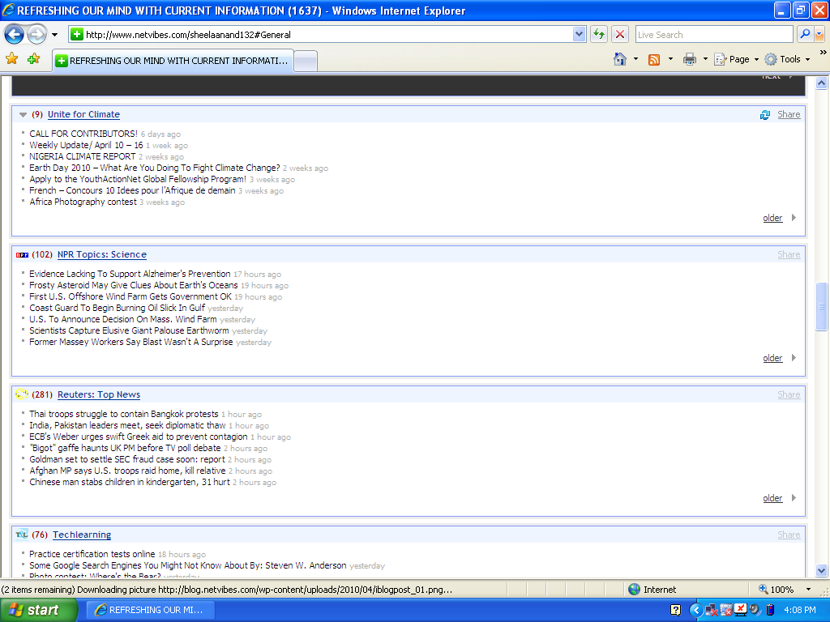

2. COMMENT ON THE BLOG:
I had become a member of classroom 2.0 and I was impressed with the Gold student online Maths enrichment program for children Grade k-6.
Gold student had very recently added video tutorials to their site ,in order to help students to learn re-learn what they may be missing in a maths education. Each video is just few minutes in length, and covers one concept.
I have appreciated their idea of maths video tutorials in classrooms, and said that I would like to implement the same in my school.
Kindly view my link:http://www.classroom20.com/profile/sheelaAnand
3. My experience on tracking changes for 3 days
I enjoyed observing the changes on Antoinette Go’s post classroom2.0,were I came across many innovative teaching styles using Web 2.0. Websites for students to upload homework was very interesting.
In the previous mail I have learnt on workshops on web2.0 for the classroom and virtual school.
United for climate was another interesting RSS feed. EARTH DAY -2010, What are you going to do for climate change ? was very informative. The significance of Earth day was well explained which in fact helped me to share the information with my teachers and students. There was a weekly update ( 28TH MARCH-APRIL 4TH)on climate ambassadors,news on united nations commission on sustainable development.
Reuters was another interesting feed where information was changing in minutes. Today’s news stated that Thai authorities intensified efforts to contain anti-government protests in Bangkok, whereas yesterdays it was given as thai troops fired live round into charging anti-government protestors.
4. Learning:
I was able to update myself on the happenings around the world in the field of education, business, politics, lifestyle, weather conditions, and environment.
The information on Earth Day2010 was very useful for me ,as our school had celebrated the Earth day on April 22nd .I was able take information from the United Climate Change site to share it with my students in the assembly.. I have shared my feeds with my colleagues to become members of netvibes and invited them to become members of classroom web2.0. In tech learning site there were many interesting facts I have come across running 3-D in classrooms which requires some specific resources. have benefited quite a lot by visiting the sites to update and refresh my knowledge.

5. Use of Net vibes in my Settings:
I shared my link with all my teachers and the Senior Management team and the senior leadership Team. Teachers were suggested to use net vibes in their subjects and create essay writing, create refection posts on various interesting topics, debate on issues and conduct quiz competitions. Sites such as tech learning, classroom 2.0 and national college of school leadership enriched us with loads of information to bring a sea change in our classrooms, especially at a time, when the Board has changed the academic system.
I am personally benefited as the information I read and learn helps a lot to have fruitful discussions’ in my meetings and also plan for group discussions, workshops extra.
In our school we have the Look Who’s Answering Quiz Club which is spearheaded by my colleague, I discussed with her on the advantage of becoming a member of net vibes and as how it can be of use to students, teachers and parents when they have to attend the quiz competition.
This is a very useful page to learn and gain an understanding on the happenings. To become worldly –wise we need to have a net vibes link.

